RESULTS ASSESSMENT REPORT

PROJECT NAME

NAME OF THE ORGANIZATION RESPONSIBLE FOR THE PROJECT

Project implementation period: xº (quarter) / xxxx (year) to xº (quarter) / xxxx (year)
Date: xx/xx/xxxx
PRESENTATION

This document is a roadmap for preparing the Results Assessment Report, which should cover at least the entire project execution period. The basic objective of this report is to consolidate information on the implementation of the project supported and the results achieved.

This document must contain information on the evolution of the project; monitoring of the output and outcome indicators agreed with BNDES; expected effects (and any unexpected effects) that have been achieved; future sustainability of these results; risks that materialized or problems that arose during its implementation; relevant institutional aspects; as well as knowledge generated and lessons learned.
Any changes in the objectives and indicators during the monitoring must be reported, the evolution of the values of these indicators must be analyzed and the values achieved compared to the predicted values (goals).
The Results Assessment Report must be completed and sent to BNDES by the institution responsible for executing the project in conjunction with the latest Project Performance Report. Besides the information provided for in this report template, the institution responsible for the project may provide any other information it deems relevant to knowing the project and understanding the results and impacts achieved.
The guidelines for completing the Results Assessment Report are in the body of this document and the BNDES team responsible for monitoring the project is available for any clarifications.

CONTENTS
CONTEXT 4
THE PROJECT 4
INTERVENTION LOGIC 5
ACTIVITIES EXECUTED 6
EFFICACY AND EFFECTIVENESS INDICATORS 7
INSTITUTIONAL AND ADMINISTRATIVE ASPECTS 9
RISKS AND LESSONS LEARNED 9
SUSTAINABILITY OF RESULTS 10
VIDEOS, PUBLICATIONS AND OTHER MEDIA ABOUT THE PROJECT 10
EVALUATION OF RELATIONSHIP WITH BNDES 11
ANNEX 1 – AMAZON FUND OBJECTIVES TREE 12

CONTEXT
Briefly describe the context of formulation and execution of the project. This topic provides, for example, information on the territory in which the project was implemented, a brief diagnosis of the problem situation the project’s actions sought to address, the public strategy or policy(ies) considered for its formulation and execution, as well as other information that facilitates the understanding of the circumstances that influenced it (up to four paragraphs).

THE PROJECT
Briefly describe the main actions and objectives of the project (up to four paragraphs).

INTERVENTION LOGIC
Describe the logic between the constitutive elements of the project, informing how the products and services implemented contribute/will contribute to solving the problem situation the project has proposed to overcome, informing the direct effects expected with its implementation, as well as the indirect long-term effects that will contribute to the general objective of the Amazon Fund, namely, “reducing deforestation with sustainable development in the Brazilian Amazon.” The description of the intervention logic of the project must comply with the expected direct and indirect effects of projects supported by the Amazon Fund (see Annex 1). The supported project may comply with one or more of the four components of the Logical Framework of the Amazon Fund, namely: (i) sustainable production; (ii) monitoring and control; (iii) land-use planning; and (iv) science, innovation and economic instruments (up to four paragraphs).

ACTIVITIES EXECUTED
This topic must provide information on the planned and executed activities, describing the main products and services (deliveries) carried out by the project (up to ten paragraphs).

OUTPUT AND OUTCOME INDICATORS
The efficacy and effectiveness indicators to be monitored stem from: (A) Logical Framework and the respective Monitoring Plan; or (B) Results Table (QR). Please follow model A or B, according to your project.
Model A: In the light of the Logical Framework/Monitoring Plan of the project (to be inserted in the format below), individually comment on the performance of the project’s output and outcome indicators and whether the predicted values (goals) have been achieved, describing the progress achieved and assessing whether the objectives have been achieved. Possible factors, controllable or not, that contributed to the results obtained and any unforeseen effects must also be discussed. Finally, describe how the project complied with the Cancun safeguards in what is applicable to it.
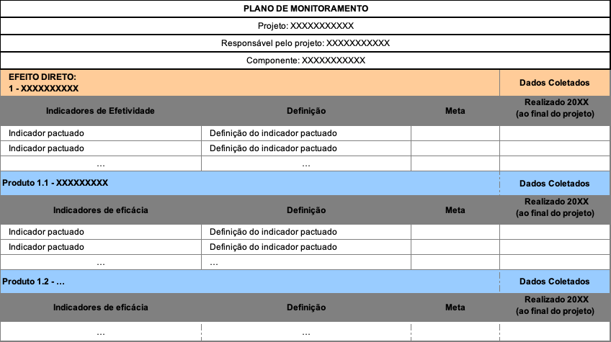
- For sustainable production projects, attach to this report the support spreadsheet used to measure annual revenues, according to the model provided by BNDES.

Model B: In the light of the Results Table (QR) of the project (to be inserted in the format below), describe the evolution and the objectives achieved. Comment individually on the performance of the output and outcome indicators of the project and whether the expected values (goals) have been achieved. Possible factors, controllable or not, that contributed to the results obtained and any unforeseen effects must also be discussed. Finally, describe how the project complied with the Cancun safeguards in what is applicable to it.
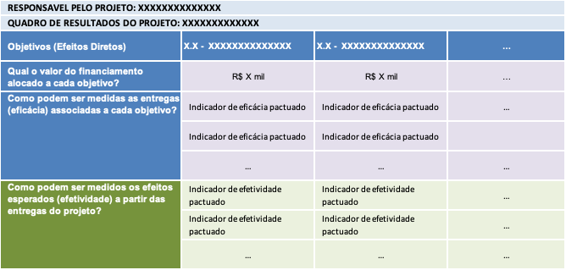
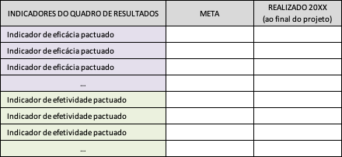
- For sustainable production projects, attach to this report the support spreadsheet used to measure annual revenues, according to the model provided by BNDES

INSTITUTIONAL AND ADMINISTRATIVE ASPECTS
Describe: (i) partnerships and cooperation established for implementing the project; (ii) changes in the administrative conditions of the organization responsible for implementing the project and aspects of the financial resource management that may have impacted its implementation; and (iii) other institutional and administrative aspects that occurred and their impacts on the project (up to four paragraphs).

RISKS AND LESSONS LEARNED
Report problems that have occurred and risks not manageable by the project that have materialized during its implementation, mistakes made, as well as successful methodologies or strategies adopted that can serve as a reference for replication. Report, for example, difficulties in implementing the project and their causes, describing the measures taken to overcome the obstacles and/or innovative ideas that were implemented and contributed to its success (up to four paragraphs).

SUSTAINABILITY OF RESULTS
Assess the extent to which the benefits of the project will last after the end of the Amazon Fund financing, from analyzing what main factors influenced achieving or not the sustainability of the project and what risks threaten the sustainability achieved (up to four paragraphs). If possible, add information on attracting new partnerships and source of funds.

VIDEOS, PUBLICATIONS AND OTHER MEDIA ABOUT THE PROJECT

Forward videos, publications and other records of project implementation and its results

EVALUATION OF RELATIONSHIP WITH BNDES
Fill in the following table, assigning grades according to the scale reported below. These grades should represent the assessment of the institution responsible for the project on the items presented.

Grade the items below according to a whole grade scale from 1 to 4, 1 being the most negative and 4 the most favorable (or report NA, if not applicable)
(a) Ease in completing the “Preliminary consultation” and interaction with BNDES in the phase of project eligibility
(b) Interaction with BNDES in the project analysis and contracting phase
(c) Interaction with BNDES in the phase of monitoring project execution and evaluating its results

The following space is reserved for recording any comments on the items graded in the previous table and for the organization responsible for implementing the project to indicate aspects that could be improved in BNDES’s performance as manager of the Amazon Fund.

ANNEX 1 – AMAZON FUND’S OBJECTIVES TREE

Examples on this topic can be taken from texts in the report of the completed projects in the “Completed projects” chapter of the Amazon Fund Activity Report 2018 – see: http://www.fundoamazonia.gov.br/export/sites/default/pt/.galleries/documentos/rafa/RAFA_2018_port.pdf
The document entitled “Conceptual framework for evaluating the effectiveness of projects supported by the Amazon Fund” lists the seven Cancun safeguards and the corresponding guiding questions – see: http://www.fundoamazonia.gov.br/export/sites/default/pt/.galleries/documentos/monitoramento-avaliacao/FA_Marco_Conceitual_Avaliacao_Efetividade_Projetos_2016.pdf
http://www.fundoamazonia.gov.br/pt/monitoramento-e-avaliacao/modelos-e-guias/
Examples on this topic can be taken from texts in the report of the completed projects in the “Completed projects” chapter of the Amazon Fund Activity Report 2018 – see: http://www.fundoamazonia.gov.br/export/sites/default/pt/.galleries/documentos/rafa/RAFA_2018_port.pdf
The document entitled “Conceptual framework for evaluating the effectiveness of projects supported by the Amazon Fund” lists the seven Cancun safeguards and the corresponding Guiding questions – see: http://www.fundoamazonia.gov.br/export/sites/default/pt/.galleries/documentos/monitoramento-avaliacao/FA_Marco_Conceitual_Avaliacao_Efetividade_Projetos_2016.pdf
http://www.fundoamazonia.gov.br/pt/monitoramento-e-avaliacao/modelos-e-guias/

